**ACTIVITY-WEEK-1**

1. **Simple Express Server with EJS**
   1. **Create a simple Express server:**
   * Set up an Express server that listens on port 3000.
   * Install and configure EJS as the templating engine.

**2: Dynamic Content with Express and EJS**

**2.1 Create a route with dynamic content:**

* + Create a new route ( **"/users")** that renders a list of users.
  + Define a list of users as an array of objects, each object containing **name** and **age** properties.

**2.2 Pass the list of users to the EJS template:**

* + Modify the route to pass the list of users to the EJS template.

**2.3 Create the EJS template to display the users:**

* + Create a **users.ejs** file in the **views** directory.
  + Use EJS to loop through the list of users and display each user's name and age in a table.

**3: Form Handling with Express and EJS**

1. **Create a route to display a form:**
   * Create a route **("/form")** that renders a form using an EJS template.
   * The form should have fields for **name** and **message**, and a submit button.
2. **Handle form submission:**
   * Set up body parsing middleware to handle form data.
   * Create a POST route **("/submit")** to handle the form submission.
   * Extract the form data from the request body and pass it to an EJS template for rendering.
3. **Create the EJS templates:**
   * Create a **form.ejs** file to display the form.
   * Create a **result.ejs** file to display the submitted data (e.g., "Thank you, [name]. Your message: [message]").

**ACTIVITY-2**

1. Setting Up the Project
2. Install Dependencies:- **npm install express ejs body-parser method-override**
3. Create the Directory Structure

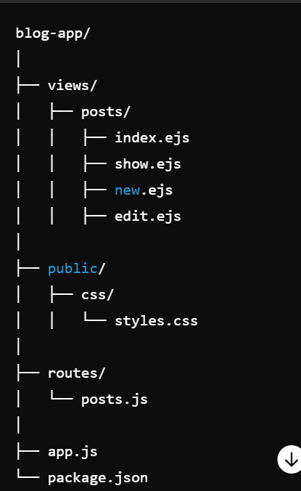

1. **Create Routes:** 
   * Create routes for viewing all posts (/posts)
   * viewing a single post (/posts/:id)
   * creating a new post (/posts/new)
   * editing a post (/posts/:id/edit)
   * deleting a post (/posts/:id/delete)
2. **Design Views:** 
   * Create EJS templates for listing all posts, showing a single post, a form for creating a new post, and a form for editing an existing post.
3. **CRUD Operations using postman & express:** 
   * Implement the Create, Read, Update, and Delete operations for the posts.